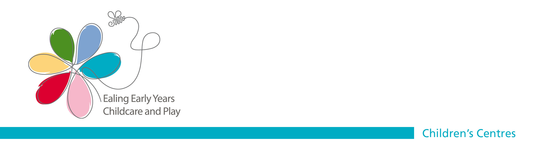
EALING CHILDREN’S CENTRES
POLICY AND PROCEDURES

FOR

SAFEGUARDING &

PROTECTING CHILDREN

Greenfields Nursery School and Children’s Centre and Havelock
Children’s Centre

Date Approved: Nov 2023

Approved by the Full Governing Board

Contents

- Introduction and aims ……………………………………………………….p. 3
- Objectives of the Policy…………………………………………………………...p. 4
- Roles and Responsibilities ……………………………………………………….p. 5
- Identifying, Reporting, referring and Monitoring Concerns …………………..p. 9
Children’s Centres Reporting Responsibilities Flow Chart ……………………….p.10
- Procedures for Raising Concerns ………………………………………………p.11
- Procedures for Making a Referral ……………………………………………….p.11
- Procedures for Monitoring Children thought/Known to be at Risk……………p.12
- Procedures for Reporting to and Attending Review Meetings………………...p.12
- Safer Recruitment………………………………………………………………….p.13
- Single Central Record……………………………………………………………..p.14
- Disclosure and Barring Service (DBS)…………………………………………..p.14
- Managing Allegations Against Staff and Volunteers ………………………..…p.17
- Training……………………………………………………………………………..p. 19
- Supporting children’s Safety Through Learning………………………………..p. 20
- Child on Child Abuse……………………………………………………………...p. 20
- Filtering and Monitoring…………………………………………………………...p. 21
- Related Policies …………………………………………………………………...p. 21
- Children’s Centre Information…………………………………………………….p. 23
- Reporting Hierarchy for Safeguarding…………………………………………...p. 23
- Useful Information………………………………………………………………….p. 24
- Key Documents…………………………………………………………………….p. 25
Appendix one – Child and Family Enquiry/Referral Form…………………………p. 26
Appendix two – LADO Referral Form ……………………………………………….p. 30
Appendix three – Types and Indicators of Abuse ………………………………….p. 33

Introduction and Aims
  - This document sets out the overarching Children’s Centre policy and procedure to be followed to safeguard children accessing services at or through a Children’s Centre in the London Borough of Ealing. This policy must be made available to all members of the Children’s Centre community in hard copy or electronically.
  - At Greenfields this policy has been adopted by the Governing Board as the overarching policy for all aspects of our work, including the Nursery School, Daycare and Children’s Centre provision at both Greenfields and Havelock Children’s Centres.
  - All parties should be familiar with its content. If this content is a variance with existing policies which would render this document ineffective the existing policies must be amended in accordance with this document.
  - However, this document does not replace existing agency or single organisation policies, but acts as a shared document to clarify safeguarding roles and responsibilities within a Children’s Centre in which a number of different services and organisations deliver services.
  - Schools and centres that let their premises to external providers or commission services themselves should also refer to the DfE’s Keeping Children Safe in Education September 2023 and supplementary document: Keeping Children Safe in Education September 2023 (Information for all school and college staff) as well as Working Together to Safeguard Children July 2022
  - The staff (and governors where applicable) of the Children’s Centre must recognise their legal duty to safeguard children, including their legal duty to refer concerns of child abuse or neglect to the appropriate investigating agency, and also recognise that this duty of care extends to protecting children from harm and neglect outside of the Children’s Centre.
  - Children’s Centre Advisory Boards must also recognise the importance of supporting the Children’s Centre community in meeting its obligations regarding safeguarding and protecting children. Safeguarding must be a standing item on the agenda.
  - The Children’s Centre follow the procedures set out in Ealing’s Child Protection Policies and Procedures (Yellow Book 2022), the London Child Protection Procedures; and (as applicable), The Early Years Foundation Stage, and the Department for Education’s Keeping Children Safe in Education September 2023.

  - The Children’s Centre is committed to:
    - Raising the profile of Safeguarding and Child Protection, Ensuring staff, volunteers and other adults understand their safeguarding responsibilities and are vigilant when at the Children’s Centre.
    - Sharing the safeguarding policy with parents on admission and by publicising this policy.
    - Establishing and implementing effective procedures for identifying, reporting, and monitoring all concerns about children/families
    - Identifying children who may benefit from Early Help. Early Help means providing support as soon as a problem emerges at any point in a child’s life
    - Ensuring that staff are aware that children with special educational needs and disabilities (SEND) can face additional safeguarding risks and reduce the barriers that can exist when recognising abuse and neglect in this group of children.
    - Establishing and implementing effective working arrangements to support children in accordance with agreed child protection/child in need plans/SAFE plans and EHAP
    - Providing a curriculum and learning environment, which promotes the development of the attitudes and skills children need to keep safe
    - Promoting online safety for staff, parents and children
    - Ensuring school IT systems have appropriate filters and monitoring to keep children safe online.
    - Establishing and implementing the recommended procedures for safer recruitment as they apply to staff, students and volunteers
    - Ongoing safeguarding training for all colleagues appropriate to their role and level of responsibility including regular attendance of DSL or Centre representative at the Designated Safeguarding Leads’ Network (4 times a year)
    - Undertaking an annual safeguarding audit using the children’s centre safeguarding audit tool; additional reviews may be required following any safeguarding incidents at the centre, however the annual audit must still be carried out

Objectives of the Policy
The objectives of this policy are to:

- Raise the awareness of everyone working at the Children’s Centre of their duty to act immediately in identifying and reporting concerns about children/families or members of staff, volunteers and professionals who work within the centre.
- Clarify roles and responsibilities in relation to safeguarding children.
- Clarify safeguarding roles and responsibilities for different organisations that deliver services at the same Children’s Centre.
- Set out the procedures for reporting initial concerns and making referrals.
- Set out the procedures for Early Help (when the concerns do not meet the threshold for significant concern)
- Set out the procedures for the ongoing monitoring of children identified to be at risk.
- Set out the procedures for reporting to and attending child protection meetings.
- Set out the procedures for safer recruitment including volunteers
- Set out the procedures for managing allegations against staff and volunteers

Roles and Responsibilities

Every service or organisation that regularly delivers services to children and families in the Children’s Centre must have a dedicated person to act as the lead on all safeguarding children issues. This person would be the Designated Safeguarding Lead (DSL).

Within each Children’s Centre there must be at least one DSL for each organisation / provider based in the centre, with the lead DSL being the overall manager or designated member of staff for the Children’s Centre.

Ealing’s Children’s Centres are configured into localities with a lead centre for each area. The DSL for the lead centre has an overarching role within the locality and must ensure good communication between DSL’s in the locality.

However, each DSL is responsible as set out in this policy for following out the requirements of this role for the services and organisation in which they are employed.

The role of the Designated Safeguarding Lead (DSL) is to:

- Take the lead in safeguarding all children accessing Children’s Centre services and day care provision.
- Ensure a named deputy Designated Safeguarding Lead is in place.
- Ensure that all staff know how to contact the DSL or their deputy at all times.
- Ensure the Centre has an induction process for all staff that introduces the Ealing Policy and Procedures for Safeguarding and Protecting Children and maintains a record of this.
- Support the staff if Early Help is appropriate, act as a lead professional, liaise with other agencies and undertake an Early Help Assessment and Plan (EHAP) with the parent/carer’s consent.
- Take the lead role in chairing Early Help meetings, maintain records, ensure that children with identified emerging Early Help Needs or an EHAP are reviewed. Also children supported under CIN or SAFE plans who attend Children’s Centres in the Locality are reviewed; at a frequency of 6-8 weeks.
- Monitor the EHAP process and consider stepping up to children’s social care if the child’s situation does not appear to be improving.
- Keep up to date with new initiatives and local and national requirements including Child Sexual Exploitation (CSE), Female Genital Mutilation (FGM), E-Safety and Prevention of Extremism
- Ensure that Centre staff have regular up to date introduction and refresher safeguarding and child protection training (within two years) and regular annual safeguarding updates.
- Keep staff local knowledge of safeguarding and child protection policy and procedures updated and in line with local guidance (Ealing safeguarding children and young people guidance. Yellow Book 2022) and government policy (London Child Protection Procedures and Guidance 2021)
- Provide advice to staff about how to take a concern or complaint forward and keep a record of all communications on CPOMS, date, time and who they discussed with (including role/agency) and when this will be reviewed and by whom. Lead DSL to review agreed actions.
- Liaise with local statutory agencies to seek any further advice and guidance as needed and record this.
- Keep securely following Data Protection Act 2018 protocols (GDPR) all records of any concerns, discussions, decisions and referrals made, these records must be made and kept using CPOMS.
- Keep an overview of all children under five supported through an EHAP within your centre (for Locality DSL within the Locality)
- Keep and monitor accurate records for all children on Child Protection, Children In Need and SAFE Plans, Children receiving High Needs Funding and those receiving Outreach support. Records should include attendance/punctuality monitoring and any other tasks set by the core group. Records should be kept securely on CPOMS.
- Contribute to and attend case conferences, core groups or strategy meetings as required.
- Participate in Locality Early Help meetings, which should include an overview of cases involving social care input known to the centre.
- Participate in High Needs meetings (locality lead DSL’s only) to review the engagement of children under 5 subject to a Child Protection Plan in their locality.
- Ensure all staff are inducted and understand their role in local safeguarding and child protection policies and procedures in line with Ealing’s Yellow Book 2022.
- Understand their role and responsibility in identifying and addressing concerns around extremism and radicalisation in accordance with Prevent Duty Guidance for England and Wales 2015.
- Ensure that child protection files of children transferring to schools are shared with the receiving school within 5 days for an in-year transfer or within the first 5 days of the start of a new term to allow the new school or college to have support in place for when the child arrives. (KCSIE Sept 22)
- In addition to the child protection file, the designated safeguarding lead should also consider if it would be appropriate to share any information with the new school or college in advance of a child leaving. For example, information that would allow the new school or college to continue supporting children who have had a social worker and been victims of abuse. (KCSIE 2022)

All DSL’s within a centre could be required once made aware of a concern to follow the procedures below. Once actions have been taken a DSL should ensure that the overarching DSL for the Centre/ Locality is aware of the concerns and the actions taken.
The Designated Safeguarding Lead (DSL) is responsible for:

- Reporting immediate concerns, where the child is considered to be at imminent risk of harm to the police by dialling 999.
- Reporting urgent concerns, including concerns relating to Prevent Duty, immediately to Ealing’s Children’s Integrated Response Service (ECIRS):
Tel: (020) 8825 8000. Please refer to Ealing Threshold of Needs and Assessment Protocol 2020.
- Following up your telephone contact with ECIRS in writing within 24 hours. Information must be sent securely via email: ecirs@ealing.gov.uk
- To seek guidance and clarity, advice can be sought anonymously from the local authority ECIRS professional consultation line 020 8825 5236.
- Obtain the consent of parent/s when making a referral unless seeking consent would:
- Put the child at further risk of harm
- Compromise a criminal investigation Or cause undue delay in taking action to protect the child
- Ensuring information is recorded and appropriate records maintained and stored securely on CPOMS
- Ensuring records and information are shared with appropriate professionals, in line with local information sharing policy.
- Managing the monitoring of attendance (including reporting), development and wellbeing of children subject to Child Protection or Children In Need plans.
- All DSLs to confirm with the overarching DSL for Centre /Locality which member of management /staff are providing supervision and guidance to staff working with children subject to Child Protection or Children In Need plans or an EHAP
- Ensuring that the Children’s Centre policies and procedures for safeguarding are known and adhered to by colleagues.
- Acting as a source of advice within the Children’s Centre, seeking further clarification when needed and ensuring their own and staff training is up to date.
- Identifying and addressing gaps in the internal safeguarding procedures as they arise and ensuring that procedures are reviewed regularly.
- Ensuring the appropriate person attends and contributes to case conferences and core group meetings using the strengthening families case conference report format (Appendices)

Allegations against staff or volunteers (ASV)
All allegations made against staff, volunteers, students or governors must be reported within 24 hours to the:
  - Local Authority Designated Officer (LADO) Natalie Cernuda Tel: 07890940241 / 020 8825 8930 Email: cernaudan@ealing.gov.uk / asv@ealing.gov.uk immediately, the LADO or a nominated person in their absence will support the DSL in following through appropriate procedures and actions. All ASV notifications must be shared with the Locality Lead.
  - Following completion of reporting your concerns, the Chair of the Governing Board must be informed.
  - Follow EYFS guidance on notifying OFSTED
  - And if the allegation is against the head/manager/proprietor this must be reported immediately to the LADO as above and to the Chair of Governors, or the next level of the reporting hierarchy (if not a school) and to:
    - Ofsted and
    - Schools Human Resources (if applicable)

The Governing Board (or lead organisation) is responsible for:

- Ensuring that appropriate safeguarding and child protection procedures are in place.
- Seeking advice from the Local Authority and Children’s Services when necessary.
- Nominating one of its members to have responsibility for safeguarding and child protection and to liaise with the DSL on all safeguarding processes and matters.
- Ensuring that the nominated governor (if applicable) undertakes child protection/safer recruitment training (as applicable) and all governors have appropriate safeguarding and child protection training at the time of induction and their training should be updated regularly.
- Reviewing the safeguarding policy and procedures annually.
- N.B. The Chair of the Governing Board (or named person in the reporting hierarchy) is the person responsible for liaising with the local authority if an allegation of abuse is made against the Head teacher/ Head of Centre.

The staff and other adults working with the children are responsible for:

- Actively protecting the children they work with, including challenging parents where any concerns have been identified (if it is judged safe to do so). For example, inappropriate handling of their child, smacking, parents/carers suspected to be under the influence of alcohol or drugs.
- Following the centres procedures.
- Immediately reporting and recording causes for concern to the DSL or their deputy. Taking the concern forward immediately in the event of the DSL and Deputy’s absence.
- Understand their duty to have “due regard to the need to prevent people from being drawn into terrorism” by being able to recognize areas of concern in relation to Prevent and to report these concerns on to the DSL.
- Providing written records stating the names of those involved i.e. children, parents, staff and date and time concerns were noted, reporting exactly what was seen and heard, this should be recorded as early as possible.
- Reporting any concerns about staff, adhering to the centre whistleblowing policy.
- To write reports as required for case conferences and core group meetings, using the strengthening families case conference report format. These must be shared with parents prior to meetings.
- Attending case conferences and core group meetings as required (staff will be given support in this).
- Reporting “near misses” where a child / adult could have potentially been at risk on the centre premises. These incidents should be recorded on the Local Authority online accident / incident reporting system. This process includes a management investigation of the incident and identifying actions to reduce risk in future.
- All staff must be aware of their role in identifying and reporting children who under the law would be considered to be privately fostered and staff must:
  - ensure that they understand the definition of private fostering
  - inform parents/carers of their legal requirement to contact ECIRS where there is information to indicate there could be private fostering arrangements
  - notify the organisations DSL and report to ECIRS by phone 020 8825 8000 and follow up in writing via secure email: ecirs@ealing.gov.uk

Identifying, Reporting, Referring, and Monitoring Concerns

Staff must be as objective as possible in observing and reporting concerns, writing down exactly what they see and hear, and keeping this distinct from their opinions and beliefs. Staff must also act sensitively at all times with the child and ensure only to ask non leading questions e.g. ‘How did you get the bruise?’ not ‘Did daddy/mummy hit you?’ It is good practice to have another member of staff within the vicinity to witness conversation.

All staff should be aware that children may not feel ready or know how to tell someone that they are being abused, exploited, or neglected, and/or they may not recognise their experiences as harmful. For example, children may feel embarrassed, humiliated, or are being threatened. This could be due to their vulnerability, disability and/or sexual orientation or language barriers. This should not prevent staff from having a professional curiosity and speaking to the designated safeguarding lead (DSL) if they have concerns about a child. It is also important that staff determine how best to build trusted relationships with children and young people which facilitate communication. (KCSIE Sept 2022)

The Children’s Centre DSL must be informed at all times if there is a safeguarding concern within the Children’s Centre. If the DSL is not the Head of Centre, they must notify the Head of Centre/manager/proprietor of all safeguarding and child protection concerns arising at the centre.

Professionals delivering services at or through the centre from an independent organisation must inform the Children’s Centre DSL if they have any safeguarding concerns relating to children using their services.

The safeguarding responsibilities of the other services and organisations are set out below in relation to a range of circumstances that may occur in a Children’s Centre:

- If a safeguarding concern is raised by a visiting member of staff about a child who is receiving a service that is delivered by the lead organisation for the Children’s Centre; the Children’s Centre DSL must be informed and take forward the complaint or concern.

The Children’s Centres DSL must inform the DSL of the other organisation of this concern and the actions being taken as long as these do not relate to the other organisation itself.

- If a safeguarding concern is raised by a member of staff about a child that is receiving a service being delivered solely by the other organisation the DSL for that service or organisation must take forward the complaint or concern.

The DSL for the other organisation must inform the Children’s Centre DSL of this concern who may then consider a joint investigation or need to take action as a consequence of this concern; for example to safeguard a sibling attending another service within the Children’s Centre.

These reporting responsibilities are set out in the following flow chart.

Children’s Centres Reporting Responsibilities Flow Chart

This flow chart does not replace: Dealing with concerns about a child/young person (Yellow Book 2014 page 41) which must be followed by all staff and organisations working in Ealing Children’s Centres.

Greenfields Nursery School and Children’s Centre and Havelock Children’s Centre
Name of lead Organisation: | Greenfields Nursery School and Children’s Centre
Name of lead Organisation’s Designated Safeguarding Lead (DSL) | Malgorzata Kojlo – Senior Safeguarding Lead  Ellie Larkin – Deputy Senior Safeguarding Lead  Supporting DSL’s  Samrita Dhillon, Raj Basra, Magda de Melo, Paula England
Please note: If the concern relates to actions of lead or other organisation, staff members follow guidance for Allegations against staff and volunteers (in Yellow Book 2014)
When following your procedures for reporting a concern regarding a child please refer to Ealing’s Assessment Protocol &Thresholds of Need Guide 2016
www.Familyservicedirectory / ESCB / Professionals/Threshold of Need and Response
A child shows signs of being in need
or
being subject to physical, emotional, sexual abuse or neglect

Immediately inform the lead Designated Safeguarding Lead (Children’s Centre) and The Designated Safeguarding Lead (DSL) for your own organisation (if different)

If you work for the lead organisation and the child is in your care

If you work for another organisation and the child is in your care

The DSL of your organisation follows procedures and reports concerns to Children’s Services ECIRS
The Children’s Centres DSL follows procedures and reports concerns to Children’s Services ECIRS

Regardless of the route taken, The Designated Safeguarding Lead involved MUST feedback to each other the nature of the concern, actions taken and the outcome of the referral (if made)

DSL must consider the needs of any siblings accessing a service delivered by the lead or other organisation at or through the centre.

If thresholds is not met for a referral the individual with concerns or the DSL should monitor the situation through the safeguarding log, or seek advice from one of Child Protection Advisor’s Team (CPA). If the child’s situation does not appear to improve, you must reconsider a referral to ECIRS,

IN AN EMERGENCY OR IF YOU HAVE A GENUINE CONCERN THAT APPROPRIATE ACTION HAS NOT BEEN TAKEN INDIVIDUALS CAN MAKE A REFFERAL DIRECTLY TO ECIRS.

Procedures for raising concerns:
When raising a concern, the following procedures will be followed:

- Staff, students, volunteers, or governors who have concerns about any child’s wellbeing or safety or any parent/carer’s behaviour, must record their concerns, using our online recording system CPOMS, the following must be included:
  - Date and time
  - What they saw and heard,
  - Who else was involved, and
  - Share this immediately with the DSL.
- When appropriate the position of marks/bruising must be plotted on a body map with information of size/colour (this can be recorded directly on CPOMS).
- All notes must be signed and dated by the person making the report.
- In order to make the process objective and maintain confidentiality, concerns should not be discussed with colleagues at this stage - the DSL will decide whether, when and how best to consult colleagues.
- The DSL will draw together the immediate evidence/concerns about the child/family to inform the decision to make a referral. This should not delay the process of a making a referral.
- In cases where threshold is not met for referral the individual with concerns or the DSL must keep a written record of concern and monitor the situation and consider early help services i.e. EHAP, Early Start referral.
- If further concerns are observed or the situation does not improve for the child, the individual with concerns must press for reconsideration around referral.
- Where you have a concern and are unsure on the actions the ECIRS Consultation Line is available for anonymous discussions regarding concerns. 020 8825 5236 Nb. This number should not be used to make referrals.
- Note: In circumstances’ such as an emergency or a genuine concern that the appropriate action has not been taken anybody can make a referral to ECIRS

Procedures for making a referral:

When making a referral, the following procedures will be followed.

- The initial contact with parent/s must be well planned to ensure child/children’s welfare and parent/s understanding and cooperation. Parents will normally be told of the referral unless this puts the child at risk, or in the case of suspected sexual abuse.
- Prepare a chronology of significant events to send with or after making the referral via the Ealing Children’s Services-Interagency Referral and Assessment Form. Note: Although this is required there must be no delay in making a referral if this information is not ready to hand.
- Phone ECIRS: Tel: (020) 8825 8000 and discuss concerns. For follow up information Email: ecirs@ealing.gov.uk. Note: If child lives in another Borough, then the Social Services in that local authority should be contacted. Never leave a message on an answer machine or email in the first instance when making a safeguarding referral, always make sure you speak to someone and record the name of the person who you have made the referral to.
- If you have made the decision not to inform the parents of the referral you must speak to a Social Worker in order to plan who will contact parent/s and when.
- If you are not contacted by a Social Worker by the time the child is due to go home, phone ECIRS again. You should phone the police if the child is about to go home and you are concerned that they are at immediate risk of significant harm.
- At the end of the referral discussion the referrer and ECIRS should be clear about proposed action, timescales and who will be taking action, or that no further action will be taken.
- All referrals from professionals should be confirmed in writing, by the referrer, within 48 hours and clearly reflect the information shared verbally at the first contact with ECIRS. Use Appendix 1 Child and Family Enquiry / Referral form.
- If the referrer has not received an acknowledgement of the referral within three working days, they must contact ECIRS again.
- Where there is to be no further action by Children’s Services, feedback should be provided by Children’s Services to the referrer about reasons for this outcome. If this information is not provided the DSL should request this and make a record of the reason for no further action in their safeguarding log.

Procedures for monitoring children thought/known to be at risk

When monitoring a child thought or known to be at risk, the following procedures will be followed:

- Written records of concern/incidents must be kept even if there is no immediate plan for a referral.
- The DSL will inform the key person of their responsibility to keep and maintain record of information about the child.
- Consider if support from Early Help Services would reduce concern, and with parental agreement instigate an EHAP or referral to Early Start team for family support.
- The key person is responsible for maintaining records of wellbeing and progress. When levels of concern are high or a child is subject to a Child Protection or Child In Need plan, daily records will be needed for detailed monitoring of the child’s emotional wellbeing; relationships; physical wellbeing; play; toileting issues etc. These records should be kept in the child’s confidential file on the Centres online system CPOMS.
- Aspects of a child’s wellbeing and progress should be discussed at team meetings when relevant to obtain feedback from all colleagues, and to plan future action as a team. These plans must be recorded and reviewed.
- The DSL must maintain a record of telephone and other relevant contacts with outside agencies, staff, and parents/carers in the child’s file.
- Any paper files must be stored in a locked filing cabinet in a lockable room.

Procedures for reporting to and attending review meetings

When reporting to and attending review meetings, the following procedures will be followed:

- The DSL notifies Children’s Services immediately of any concerns or unauthorised absences involving Looked After Children and children subject to Child Protection or Child in Need plans and records it on the child’s file.
- The DSL and/or the child’s key person provide reports for and attend case conferences, core group meetings, and professionals’ meetings as required.
- On transfer, records are passed on as appropriate to the DSL at the receiving school. If the child is currently subject to a CP/CIN plan and agreement has been provided by the lead professional. Centre or childcare provision must keep a photocopy of these records with the Children’s Centre for 3 years after which they are archived for the required duration as outlined in the GDPR regulations. (EHAP protocol is to be saved for 10 years in total).

Safer Recruitment
The Children’s Centre follows the Safer Recruitment Practices outlined by Keeping Children Safe in Education (September 2023), which aims to identify people who might be harmful or unsuitable at the outset, and prevent them from working with children.

The Children’s Centre aims to ensure insofar as is possible, that anyone seeking paid or voluntary work at the Children’s Centre is safe to work with children by following Safer Recruitment Practice.

The Children’s Centre expects all staff and volunteers to share commitment to safeguarding and promoting the welfare of children.

Safer Recruitment requires the Children’s Centre to embed child protection and the safeguarding of children at every stage of the recruitment and selection process.

When recruiting staff, the following procedures will be followed:

- At least one member of the interviewing panel will have attended appropriate safer recruitment training
- Ensuring job descriptions clearly state the responsibility staff have for safeguarding children and promoting their welfare.
- Including specific reference to applicants’ suitability to work with children in future person specifications.
- Use of application forms, which include necessary statements relating to the Rehabilitation of Offenders Act, and a Safeguarding Statement, which summarises the vetting process that will be undertaken. (Reference Local Authority Application Forms)
- Scrutinising applicants’ education and employment history.
- Completely resolving apparent gaps/discrepancies in the application (including gaps in employment) at the interview stage, all gaps /discrepancies must be accounted for.
- Obtaining independent references to assess the applicants’ suitability to work with children and addressing concerns that may arise.
- Children’s Centres must ask for previous allegations founded and unfounded and if subject to any disciplinary procedures even if time scale is spent.
- A formal interview, which will include questions relating to safeguarding of children.
- Verifying the successful applicants: identity, academic/vocational qualifications, employment history and experience and resolving anomalies, health and physical capacity for the job.
- Checking candidates online activity as set out in centre procedures.
- Processing the application for and obtaining clearance from the Disclosure and Barring Service (DBS) for an Enhanced DBS check before staff take up employment (see page 14 of this policy and procedures)
- In exceptional circumstances if a staff member is required to start before a satisfactory DBS check has been received a risk assessment must be carried out, reviewed and signed by the overarching DSL. The member of staff must never be left unsupervised with children.

Single Central Record

The Children’s Centre keep a Single Central Record of Recruitment and Vetting checks and a Record of ID Checks for all staff, students and volunteers who work or deliver services at the centre.

The Single Central Record of DBS disclosures should include details of:

- Name
- Role
- Organisation
- DBS number
- Date of DBS Disclosure
- Confirmation that the Head of Centre or a person delegated by them has had sight of this disclosure
- Confirmation that the Head of Centre or a person delegated by them has seen proof of identification such as a passport or Photo ID from a statutory agency or organisation contracted by the Local Authority. Copies of disclosures must not be kept on site.
- For national and external organisations recognised by the LA such as NHS healthcare professionals or LA maintenance teams you should expect to be provided with the full DBS details. In some instance a formal letter from their organisation that clearly outlines that staff have all received DBS clearance will be sufficient. This letter should be annually updated by the Locality Lead.

Disclosure and Barring Service (DBS)
Link for updated guidance on Regulated Activities please check to ensure latest guidance is followed.

ES573374_CCS156_CCS0318265556-1_NHS Eligibility Roles Leaflet_Children_v3_EB.pdf (publishing.service.gov.uk)

Children’s Centres provide regulated activity (children) as set below:

- Regulated activity includes unsupervised activities e.g. teaching, training, instructing, care or supervision of children or providing guidance or advice on well-being, driving a vehicle for children only.
- Regulated activity also includes work for a limited range of establishments (specified places) where there is an opportunity for contact e.g. schools, children's homes, children’s centres and childcare premises (but not work by supervised volunteers – unless this is frequent see point 5 below)
- If you are on the payroll working at a school / children’s centre / childcare provider, this is classed as Regulated Activity
- Contractors or any employee of the contractor has to have an appropriate level DBS checks. Contractors engaging in regulated activity will require and enhanced DBS certificate (including barred list information). For all other contractors who are not engaging in regulated activity, but whose work provides them with an opportunity for regular contact with children, an enhanced DBS check (not including barred list) will be required. When considering whether the contact is regular (regular is defined as carried out by the same person frequently (once a week or more often), or on 4 or more days in a 30-day period, it is irrelevant whether the contractor works on a single site or across a number of sites) Temporary and maintenance workers are not in regulated activity, it is the school's children’s centre and childcare providers responsibility to ensure the safety of the children through supervising these staff at ALL times.
- Frequency and intensity comes into play with children. Even if a role is unregulated e.g. volunteer, if they were to be at the school / children’s centre / childcare provider once a week or four times in a month, because of the frequency they would need to have a DBS check carried out, but not a Barred List check.
- Those roles that used to be in Regulated Activity but are no longer in Regulated Activity (i.e. they are fully supervised) can still have an enhanced DBS check but no Barred List check.
- Parent volunteers on school or centre trips need to be supervised at ALL times and it is the school’s children’s centre or childcare provider’s responsibility to ensure this happens.

Disclosure and Barring Service checks
These are the types of checks available to those working with children: Type of check | What the check involves | Positions eligible for this level of check
Standard check | Check of the Police National Computer records of convictions, cautions, reprimands and warnings | The position being applied for must be covered by an exempted question in the Rehabilitation of Offenders Act 1974 (Exceptions) Order 1975.
Enhanced check | Check of the Police National Computer records plus additional information held by police such as interviews and allegations. Additional information will only be disclosed where a Chief Police Officer reasonably believes it to be relevant and considers that it ought to be disclosed. | The position being applied for must be covered by an exempted question in the Rehabilitation of Offenders Act 1974 (Exceptions) Order 1975 and by provisions in the Police Act 1997 (Criminal Records) Regulations 2002.*
Enhanced criminal record check with children’s and/or adult’s barred list information | Check of the Police National Computer records plus additional information held by police plus check of the DBS Children’s Barred List plus check of the DBS Adults’ Barred List. | The position must be eligible for an enhanced level criminal record check as above and be for a purpose listed in the Police Act 1997 (Criminal Records) (No.2) Regulations 2009 as qualifying for a barred list(s) check.

For staff working in a regulated activity schools, children’s centres, child care providers, managers must apply for the: Enhanced criminal record check with children’s and/or adults’ barred list information, check.

For staff (or volunteers work who work frequently) in a regulated activity and are supervised (and as such this could be classed as an unregulated activity) schools, children’s centres, child care providers can apply for an: Enhanced check
Guidance for supervision of volunteers is set out clearly in Annex D: statutory Guidance – regulated activity (children)

Frequency of DBS checks
Schools, Children’s Centres and childcare providers must follow guidance on frequency of DBS renewal that relates to their service type and organisation as follows:

- Ealing Council Children’s Services staff:
  - Enhanced check with barring on starting employment in a regulated activity and on change of job, change in circumstances that would have implications for the check and or renewed every three years
  - Enhanced check on starting employment in a regulated activity and on change of job, and or change in circumstances that would have implications for the check
- School and external child care provider staff:
  - Enhanced check with barring on starting employment in a regulated activity and on change of job and or change in circumstances that would have implications for the check
- All employees who work in a regulated activity and have undertaken a DBS check have an obligation to notify their manager/employer of any incidents that may affect this status. Manager must then carry out an additional check.

Managing Allegations against staff and volunteers ASV (Allegations Against Staff)
The Children’s Centre has a professional duty to provide a safe and happy environment and nurturing ethos, which fosters confidence, independence and learning, and:

- Recognises the importance of close contact with trusted adults for young children’s healthy development and its importance in building self-esteem and positive attachments between the staff and the children and their families. This is especially important for the youngest children who require the greatest amount of physical care, handling, and comforting.

- Fosters the development of natural relationships between staff and children based on care, respect and love for the children, which includes close physical contact and warmth. This sort of contact is not encouraged with students, volunteers and short-term agency staff. Everyone is nevertheless, expected to always observe professional and appropriate boundaries in their relationships with the children.
.
To ensure a safe environment, the following procedures will be followed:

- Activities where staff are alone with a child or group of children for a short period of time – e.g. during story times, must be planned, agreed and recorded by the Centre Head or delegated manager to ensure that staff qualification and ratios are met at all times, and risk assessment carried out as appropriate.
- Childcare and nursery provision within Children’s Centres must abide by the “Statutory Framework for Early Years Foundation Stage Sept 2021 staff and child ratios.
- Students, volunteers, visitors or agency staff are not allowed to be alone with children (with the exception of agency staff/students on long term placement who have been observed to work safely and respectfully with the children over a period of time and agreed and recorded by Head of Centre or delegated manager and have DBS clearance.
- The changing areas are:
  - Open to main areas so staff are not shut off alone and out of sight with children.
- Permanent members of staff should change children’s clothes, or long-term agency staff, that have a key person role. This should be agreed and recorded by Centre Head or delegated manager.
- Staff must inform colleagues when they are changing a child.
- Staff must keep a record of nappy changes, or changes of children’s clothing, toilet training and any other occasion when it is necessary to change a child or help them in the toilets.
- If parents take their own child to the toilet area, staff must ensure that no other children are left alone in this area at the same time.
- Contractors working on site must not be allowed in changing areas if children are being changed.

In the event of an allegation being made against staff the procedure is to:

- Report the allegation to The Designated Safeguarding Lead (DSL) except for allegations against the DSL, which must be reported to the person who is at next level of management).
This person will report it to The LADO, Natalie Cernuda Tel: 07890940241 / 020 8825 8930 immediately and follow up information can be sent securely via Egress Email: cernudan@ealing.gov.uk / asv@ealing.gov.uk. Following the referral the Chair of the Governing Board should also be informed.
The person who has reported the incident to The Designated Officer must not talk to any members of staff or other person until advised to do so by The LADO. The member of staff concerned must not be told about the subject of the allegation as this can hinder and affect the investigation procedure.
- All communication and related evidence and actions must be recorded, dated and signed.
- The LADO will consult as necessary with the Head of Centre/Police/Child Protection Advisor and HR to consider the evidence/information and will advise on the required course of action.
- Refer to Ealing’s Yellow Book 2022, for more detailed procedures.
- Organisations must follow their own procedures regarding Allegations against staff and volunteers (ASV) and if the requirements are met for a member of staff to be temporarily relocated, redeployed or suspended this must be actioned accordingly.
- The manager responsible must only communicate information with the affected member of staff as agreed by the LADO, e.g. to state the reasons for management action are than an allegation has been made not what the allegations relates to)
- See policy on ‘Responding to Allegations of Abuse Made Against Teachers and Other School Staff’ for further detail.

Training

To ensure safe practice the following training must be undertaken:

- The Designated Safeguarding Lead must undertake Ealing Safeguarding Children Partnership approved training through attendance at Ealing Safeguarding Children Partnership or other relevant Governors Safeguarding Training.
- There is also an expectation that the DSL attend other relevant ESCP multi-agency training.
- Requirement to attend DSL training and the DSL network meeting which is run 5 times a year to keep up to date with relevant safeguarding priorities.
- The Designated Safeguarding Teacher must update their training every two years.
- Whole staff group and or individual training will be undertaken every 2 years or more often if required. This training should meet the requirements of Ealing Safeguarding Children Partnership.
- Ensure that staff are trained properly and understand their duties under Prevent
- All staff must have an awareness of presentations that could indicate that a child is experiencing abuse or neglect.
- All staff must be aware of their roles and responsibilities and the need to use local and national policies and procedures to inform their practice.
- Every member of staff has a role to play in keeping children safe. They must pass on any information or concerns about the safety of a child or young person to The Designated Safeguarding Lead
- All concerns should be recorded on the centre online recording system CPOMS.
- The Designated Safeguarding Lead will ensure their own and other staff training is kept up to date and will keep a log of all relevant training. This will include options for on-line training modules that can be accessed from Ealing Safeguarding Children Partnership.
- If the Children’s Centre is led by a school:
  - The governing board training must adhere to the requirements of Keeping Children Safe in Education September 2023.
  - Staff safeguarding training will include roles and responsibilities in relation to filtering and monitoring.
  - The Head of Centre and the Chair of Governors or a nominated governor will attend appropriate Safer Recruitment training as required by legislation.

- Supporting children’s safety through learning
The time that children at risk spend at nursery may be the only stable and predictable part of their lives.

It is especially important to provide children in these circumstances, with a secure, caring environment and a curriculum that is based directly on their observed developmental and care needs, capabilities and interests. For example, in knowledge and understanding of the world the children will learn how to keep themselves safe when walking on the pavement near traffic. The Key Person system enables the Children’s Centre to do this on an individual basis.

The Children’s Centre recognises the fundamental role that children’s personal, social and emotional development plays in their wellbeing and their ability to develop and learn ‘normally’ – as well as the potential impact it might have on their ability to stand up for themselves and keep themselves safe. Within Children’s Centres we promote the fundamental British Values of Democracy, Rule of Law, Individual Liberty and Mutual respect and tolerance of others

The Children’s Centre therefore plan to:
- Build children’s self-esteem, self-awareness, and self-confidence.
- Build their ability and willingness to say what they want/need and speak up for themselves, knowing they will be listened to.
- Help them understand boundaries and acceptable behaviour.
- Help them understand that they have the right to feel safe and not be frightened.
- Help them deal with conflicts by talking, explaining their motives and negotiating.
- Teach them to say no if they don’t like something/don’t want to do something.
- Help them think about keeping safe/keeping away from danger.
- Teach them where to go for help and how to ask for it.
- Teach them to treat others as they would want to be treated themselves.

- Child on Child Abuse
Child on child abuse can take many forms and can take place without the knowledge of adults within a school. Some examples of child on child abuse are; bullying (including cyberbullying, prejudice-based and discriminatory bullying); abuse in intimate personal relationships between peers; physical abuse which can include hitting, kicking, shaking, biting, hair pulling, or otherwise causing physical harm. This list is not exhaustive and as children grow beyond the early years there are many other types of child on child abuse that should be considered, as outlined in KCSIE 2022.

At Greenfields Nursery School children are taught in an open plan environment where they are observed by caring and trusted adults all of the time. There is a strong focus on; children’s personal, social and emotional development; on teaching our children to respect their peers when talking and playing together; learning how to touch one another appropriately and how to respond if a friend does something that they do not like.

A central value at Greenfields is one of ‘listening’, ensuring that children, staff and parents feel listened to and heard and have opportunities to share their thoughts, feelings and thinking on any matters that are of importance to them. Children are actively encouraged by their keyworkers and other close adults to talk about things that upset or concern them. This will support our children as they grow and develop to be able to talk to others about any forms of abuse or violence that they may encounter in their lives.

- Filtering and Monitoring
Schools in England (and Wales) are required “to ensure children are safe from terrorist and extremist material when accessing the internet in school, including by establishing appropriate levels of filtering” (Prevent Duty Guidance April 2021). Furthermore, the Department for Education’s statutory guidance Keeping Children Safe in Education (2023) obliges schools and colleges in England to “ensure appropriate filters and appropriate monitoring systems are in place and regularly review their effectiveness” and they “should be doing all that they reasonably can to limit children’s exposure to the above risks from the school’s or college’s IT system”

At Greenfields the Headteacher, School Business Manager, Designated Safeguarding Lead and IT consultant RX Designs are responsible for the filtering and monitoring systems within the school. The children attending Greenfields are young and therefore all security systems are set to ensure that all harmful and explicit content is blocked; this includes (but is not exclusive to) anything related to: pornography, discrimination, drugs, extremism, self-harm, violence and child exploitation or sexual harm.
In addition to this staff also ensure that:
- children are always supervised when accessing the internet.
- all websites / media to be used with children are checked and reviewed before use.
- the DSL is notified immediately of any unsuitable content that has been accessed on the school system.
- they do not download any applications or software onto school devices without permission.
- only school IT equipment is used in the classrooms and with children.
- they are aware of the most current advice / guidance for parents and where parents can access this. (Links to guidance is available on the safeguarding page of the school website)

The Headteacher, School Business Manager, Designated Safeguarding Lead and IT consultant RX Designs will carry out an audit using the DfE filtering and monitoring standards on an annual basis. The following policies will give further information: Code of Conduct for School Employees, Electronic Information and Communications Policy, Information Security Policy, Mobile Phone Portable Devices and Camera Policy.

- Related Policies
This safeguarding policy and procedures should also be read in conjunction with the following documents and policies:
- The health and safety policy and related risk assessments
- Antibullying policy and procedures
- Behaviour management policy
- Procedures for meeting the needs of pupils with medical conditions
- Procedures for first aid
- Policy for managing intimate care (toileting)
- Mobile phone and camera policy
- Whistleblowing policy
- Expectations and rules around the use of the internet on site by staff, parents and children
- Recruitment of staff.
- Low Levels Concern Policy
- Code of Conduct for School Employees
- Electronic Information and Communications Policy
- Information Security Policy
- Mobile Phone Portable Devices and Camera Policy.

Children’s Centre Information

At Greenfields Nursery School and Children’s Centre and Havelock Children’s Centre, Malgorzata Kojlo, Extended Services Manager is The Designated Safeguarding Lead (DSL); this person is the nominated safeguarding advisor for the lead agency or organisation managing the centre.

In his or her absence this role is covered by Ellie Larkin, Headteacher

The above named Designated Safeguarding Lead or deputy will report through the following line management hierarchy: (add additional rows if required)

Reporting hierarchy for safeguarding
Name | Role in organisation | Reports to | Role in organisation | Phone number/s
Ellie Larkin | Headteacher | Susannah Abbott | Chair of Governors
Malgorzata Kojlo | Extended Services Manager | Ellie Larkin | Head of Centre | 020 8813 8079

The organisations that regularly deliver services to children and families in the Children’s Centre must inform the lead Designated Safeguarding Lead who The Designated Safeguarding Lead for their organisation is. This information must be entered in the table below.

Name of service /organisation | Name of Designated Safeguarding Lead(DSL) | Role in organisation | Contact Details
Early Start/ Health Visitors | Desta Williams | Locality Lead, Early Start (SWE) | 07776670934
Speech & Language Services | Ami Mathur | Clinical Head of S&L Therapy | 07548141424
Educational Psychology | Judith Chambers Thomas | Principal Educational Psychologist | 020 8825 8775
Occupational Therapy | Anette Steenkamp  Yingherng Heng |  | 0208 825 8768
Physiotherapy | Rachel Brunton |  | 0208 825 8702
Twinkle Tots Day Nursery | Susan Dhillon | Nursery Manager | 020 8845 6000

Useful Information

The Designated Officer (LADO) | Natalie Cernuda  Tel: 07890940241 / 020 8825 8930  Email: cernudan@ealing.gov.uk / asv@ealing.gov.uk
Child Protection Advisory Line | Tel : 020 8825 8930
Ealing Children’s Integrated Response Service | Tel: 020 8825 8000  Email: ecirs@ealing.gov.uk
Ealing Council Human Resources | Mark Nelson: Tel: 0208 825 9478  Email: mnelson@ealing.gov.uk
Police Child Protection Team | Tel: 020 8246 1901
Assistant Director Early Years, Preventative and Youth Services | Angie Dennison Tel: 020 8825 6383  Email: DennisonA@ealing.gov.uk

The Children’s Centres policy and procedure should be used in conjunction with Ealing’s Yellow Book 2022 (Ealing Safeguarding Children Guidance).

The Yellow Book 2022 is the key reference document for all staff, students and volunteers working with children and young people in Ealing, and has informed this Children’s Centre Policy and Procedures.

Key documents

Child and Family Enquiry Form ECIRS (attached)
ASV LADO Referral Form (attached)

See below which key documents are accessed in Ealing’s Yellow Book 2014 (YB):

Information:
Children’s Centre Safeguarding Policy statement for parents( for parents notice board) | Appendix 3
Role Specification for the Designated Safeguarding Lead | Chapter 8 YB
Promoting Safe Practice: Code of Conduct for Staff | Chapter 25 YB
Forms:
Incident Report Log | Appendix 4 YB
ECIRS enquiry form | Appendix 1
ASV LADO referral form | Appendix 2
Flowcharts:
1. Dealing with concerns about a child / young person flowchart | Page 41 YB
2. On-line safety incident flowchart | Page 51 YB
3. Flow chart for key questions for information sharing | Page 23 YB
4. Allegations against staff and volunteers flowchart | Page 69 YB
Supporting information:
Additional page | Appendix 4

Appendix 1 Child and Family Enquiry/Referral
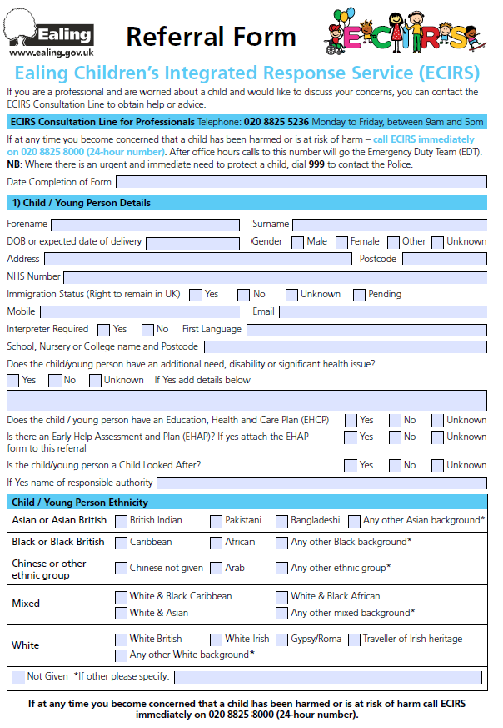

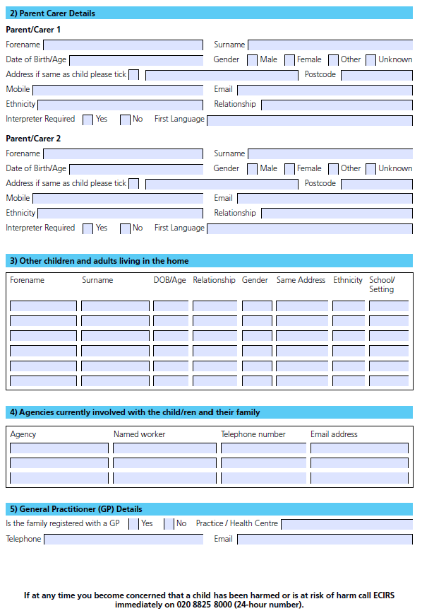

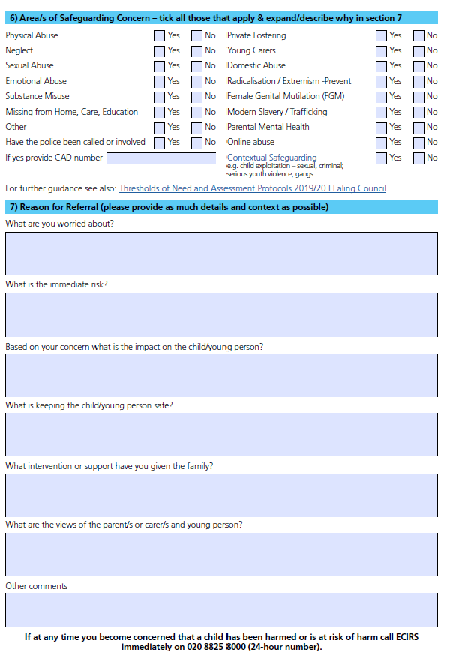

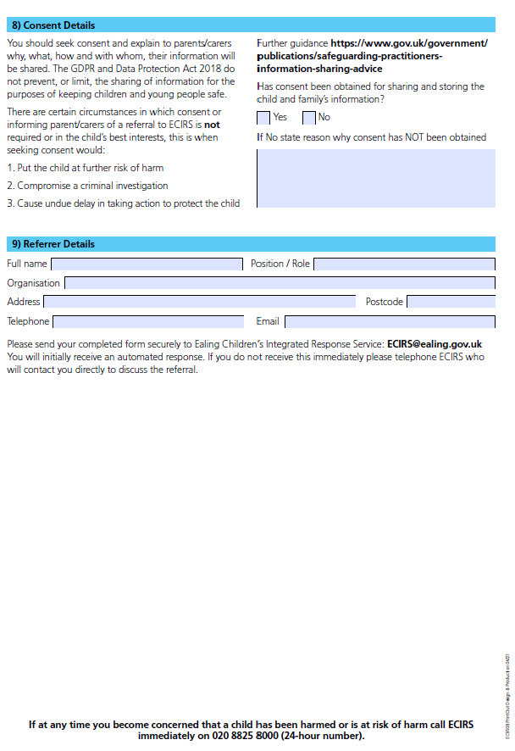

Appendix 2 – LADO Referral Form

MULTI- AGENCY REFERRAL WHEREBY AN ALLEGATION HAS BEEN MADE AGAINST STAFF OR VOLUNTEER WHO WORKS WITH CHILDREN
Note to Referrers:
This form should be used to make a referral to children’s social care, regarding a staff member/volunteer against whom an allegation has been made, in line with Chapter 7 of the London Child Protection Procedures, Keeping Children Safe in Education and Working Together 2015.

Once completed please return securely within 1 working day of the incident to: aap@ealing.gov.uk or child.protection@ealing.cjsm.net
Contact telephone number for LADO queries: 020 8825 8930

LADO REFERRAL FORM
Incident Date
Referral Date
Reason, if more than 24hrs since incident
Details of Staff/Volunteer subject to Allegation:
Name of staff/volunteer

Date of Birth
Language spoken
Ethnicity
Home/main address incl. postcode
Occupation
Place of Work address
Details of Employer/organisation:
Name of employer/organisation
Address
Contact name and tel number
Details on Children involved:
CP Process initiated?
Name of allocated social worker /team
Name/s and dates of birth of child/ren
Home address
Language spoken
Ethnicity
Does allegation relate to child’s LAC placement?
Details of Referrer:
Name
Contact tel number
Position/role
Name and address of organisation
Details of the Allegation:
Please provide the following information regarding the allegation
- Details of the allegation
- Date/s of the allegation
- Details of where the incident is alleged to have taken place
- Details of any injuries
- Details of any witnesses and involvement of police or other agencies to date
- What actions have been taken forward to date i.e. has the professional been suspended or moved to a different place of work
Main abuse category | Physical sexual emotional neglect  If physical did  allegation result  from staff/volunteer  using authorised  physical intervention?
What safeguarding arrangements have been put in place for the child?
Are there any relevant concerns about the child we need to be aware of?
Have Human Resources been informed?

Feedback to Referrers:
Your referral will be forwarded to the LADO who will aim, as a guideline, to respond to your referral within 24 hours.

Please contact us
- If you do not hear back from us within 3 working days regarding the outcome and/or progress of your referral
- If you wish to discuss the decision made regarding your referral
- If you encounter any difficulties in relation to your referral that you wish to bring to the attention of the LADO

Appendix 3 – Types and Indicators of Abuse

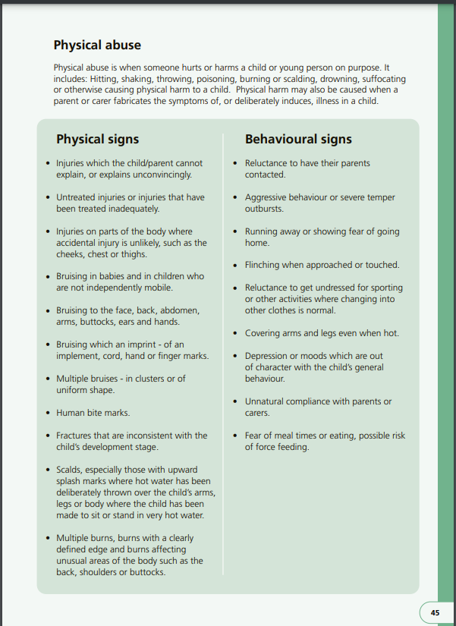

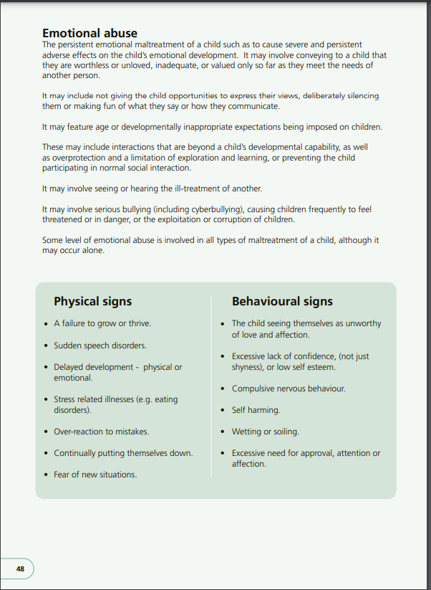

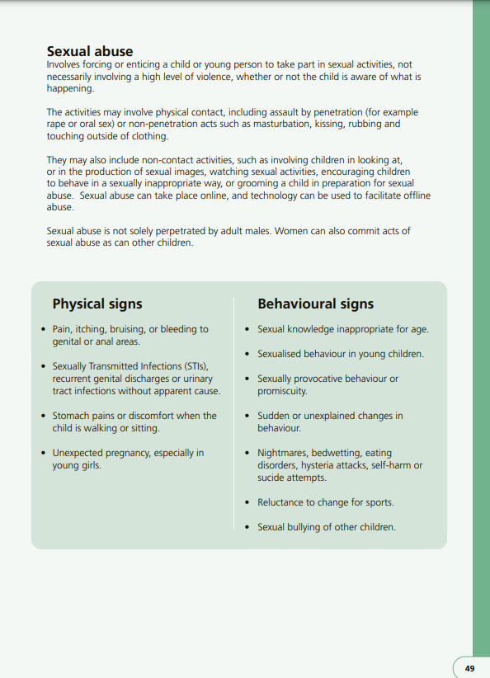

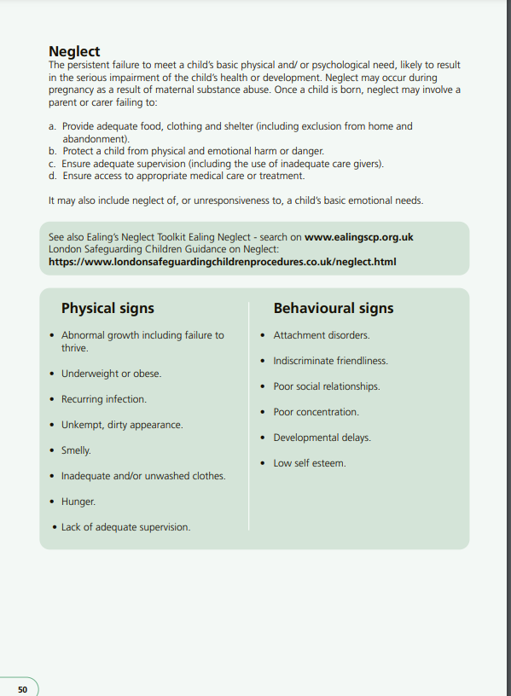

Appendix 3

Children’s Centres Child Protection Statement
Children centre staff (and governors if a school or nursery school) have a legal duty to safeguard children, including a duty to refer concerns regarding the safety of a child to the appropriate service. This duty of care includes protecting children from harm outside of the children’s centre.
This centre works to safeguarding and child protection policies and procedures which are available for parents and families to see on request.

Keeping children safe is at the centre of all we do, we will:
- Provide a safe place for children and their families

- Listen to children, young people and families

- Value and treat children, young people with respect

- Support children and families to develop skills to keep themselves safe

- Provide a named person at the centre who has overall responsibility for safeguarding and protecting children.

- Ensure parents know the name and contact details of the centre’s Nominated Safeguarding Person.

- Ensure all staff, students and volunteers have appropriate checks so they can work at the centre.

- Train all staff on local policy and procedures for safeguarding and protecting children

- Follow up concerns raised about staff, students or volunteers working in the centre which will affect the safety of children.

- Act on all safeguarding concerns immediately

- Discuss concerns with parents, before making a referral regarding the safety of a child unless there is a risk of further harm to the child.
Nominated Safeguarding Person | Contact Details
Deputy Nominated Safeguarding Person | Contact Details

Supportive Action for Families in Ealing
Early Help Assessment and Plan
Advice must be sought through DSL from Ealing Children’s Integrated Response Service (ECIRS)
General Data Protection Regulation May 2018
Revised Prevent Duty Guidance: for England and Wales 2015
Revised Prevent Duty Guidance: for England and Wales July 2015
Private Fostering: What is your role (Ealing Children’s Services Leaflet)
Keeping children safe in education Statutory guidance for schools and colleges / Ealing Council DBS guidance 2015
See Keeping children safe in education Statutory guidance for schools and colleges Sept 2023 for references
See Keeping children safe in education Statutory guidance for schools and colleges Sept 2023
Revised Prevent Duty Guidance for England and Wales 2015

